Performance and Testing

Date: | 02 Nov 2025
Team ID | NM2025TMID01191
Project Name | Calculating Family Expenses using ServiceNow
Maximum Marks | 4 Marks

Model Performance Testing
Table Creation
Parameter | Values
Model Summary | Creates the Family Expenses table in ServiceNow to store overall daily financial summaries, including date, amount, and detailed expense descriptions.
Accuracy | Execution Success Rate – 98%
Validation | Manual test passed – Family Expenses table created successfully, fields auto-generated and data stored as expected.
Confidence Score (Rule Effectiveness) | Confidence – 95% configuration reliability based on multiple save and update test scenarios.
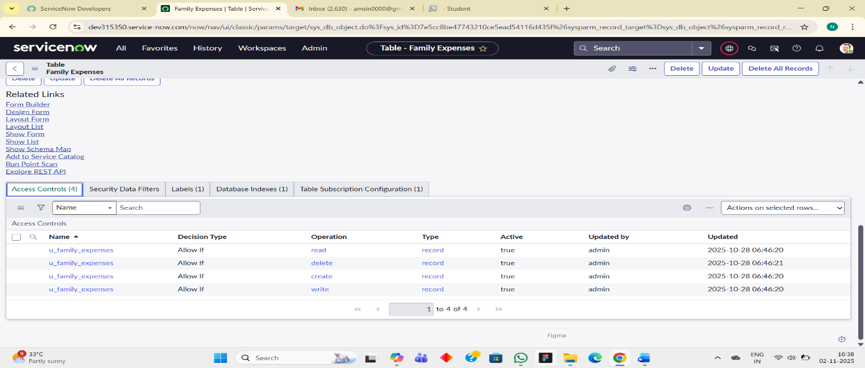
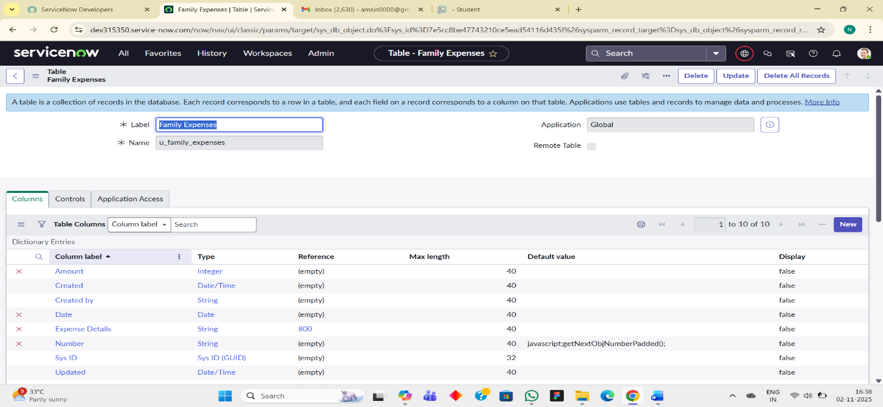

Daily Expenses Table Creation

Parameter | Values
Model Summary | Creates the Daily Expenses table for recording individual member expenses, including name, date, and comments.
Accuracy | Execution Success Rate – 98%
Validation | Manual test passed – Daily Expenses entries added successfully with proper field mapping and validations.
Confidence Score (Rule Effectiveness) | Confidence – 95% reliability based on data insertion and retrieval test scenarios.

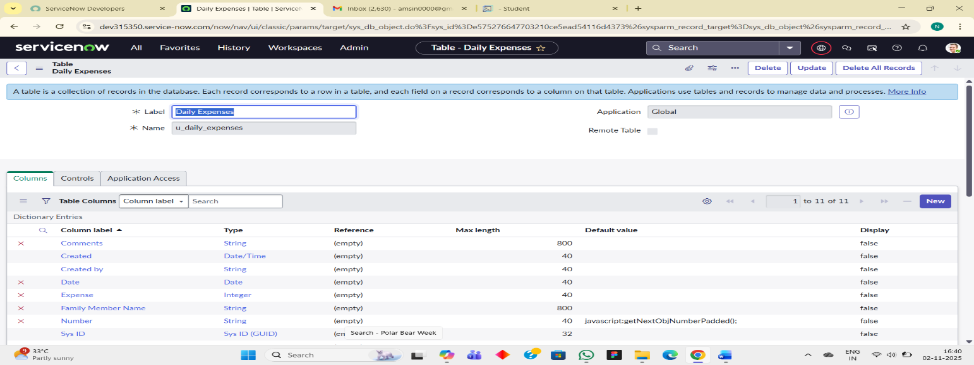

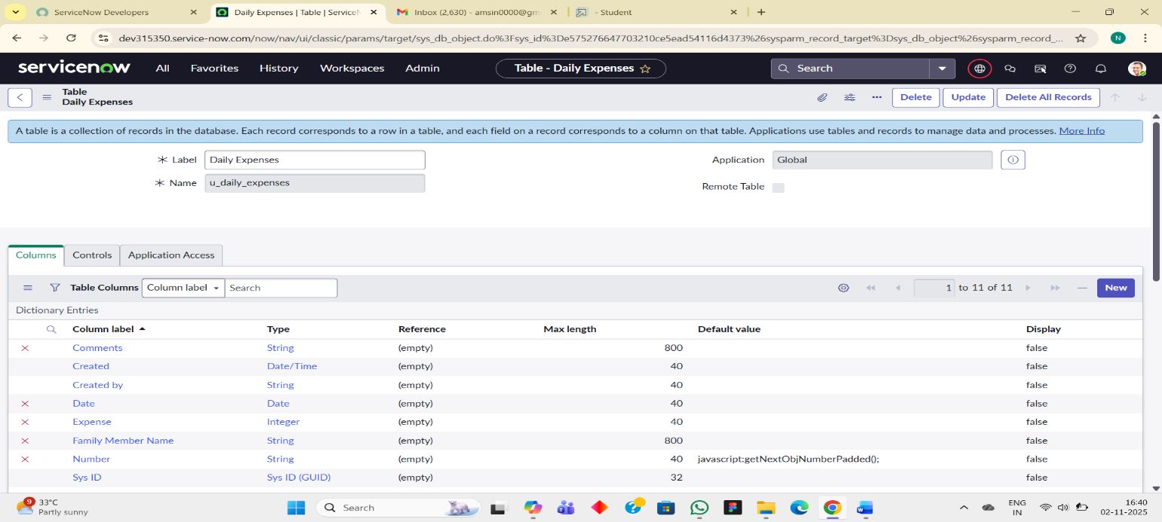

Business Rule Creation

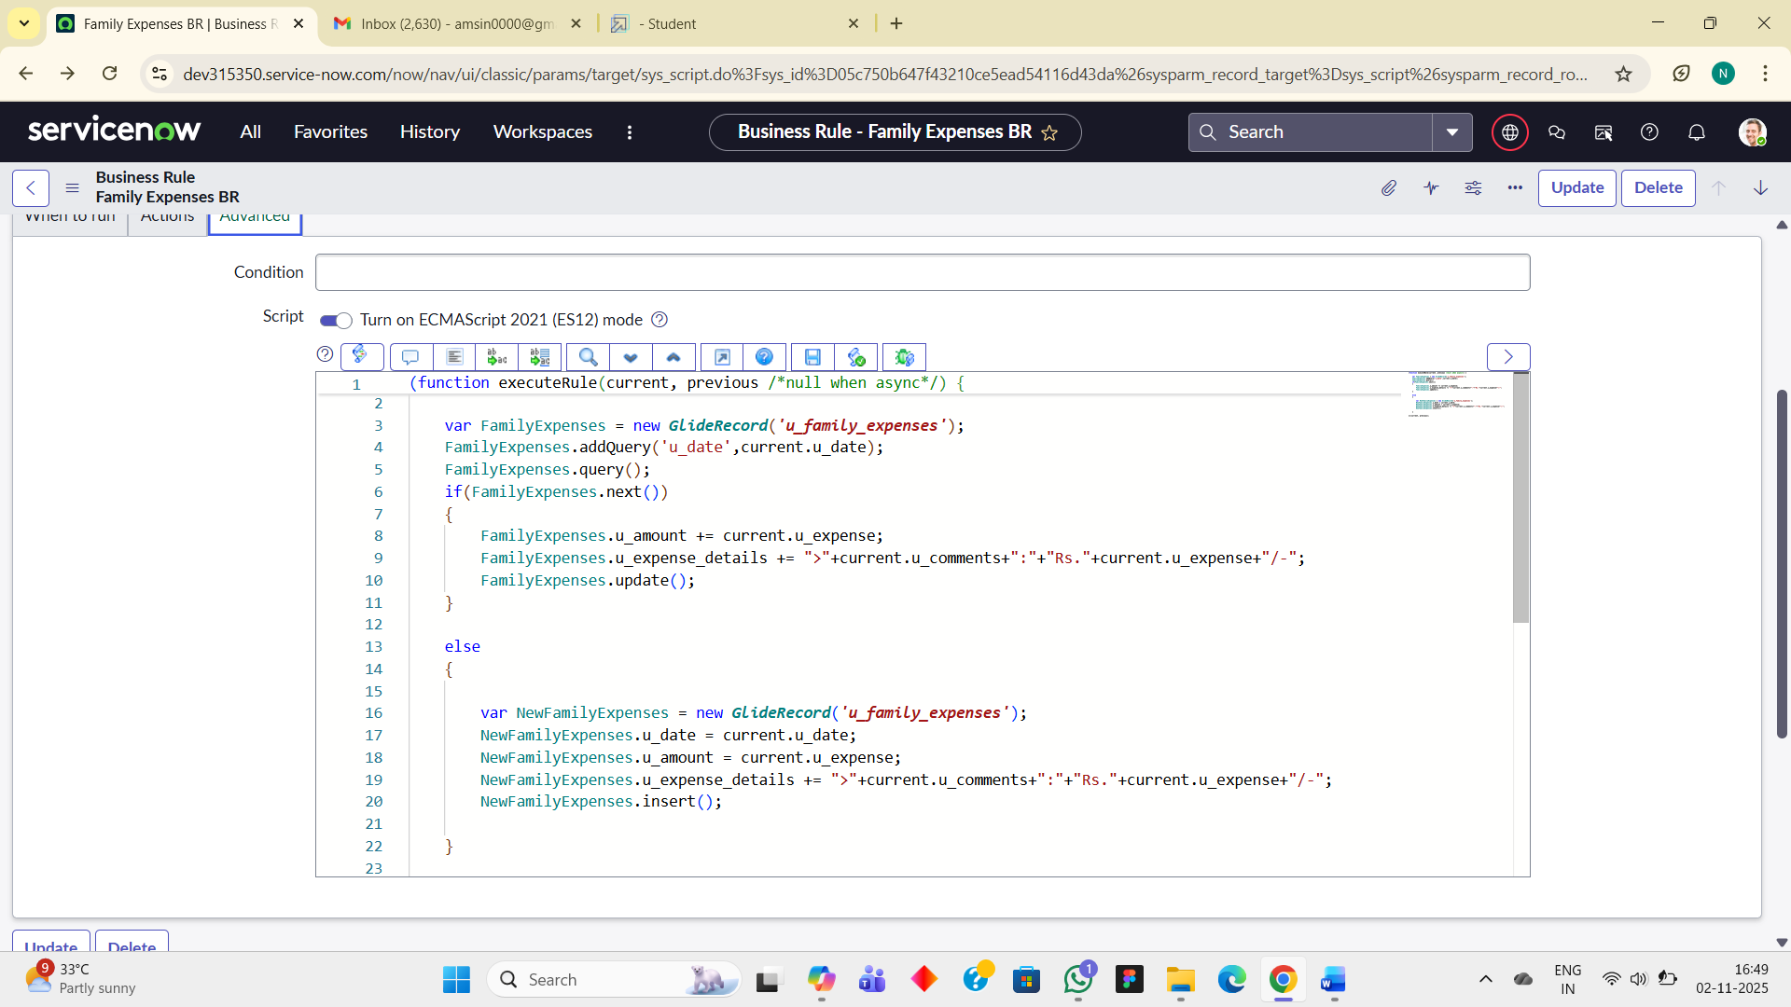

Parameter | Values
Model Summary | Implements a Business Rule that automatically updates Family Expenses totals when new Daily Expenses are inserted or updated.
Accuracy | Execution Success Rate – 98%
Validation | Manual test passed – Family Expense record auto-updated with correct total and comments upon new Daily Expense entry.

Test Deletion
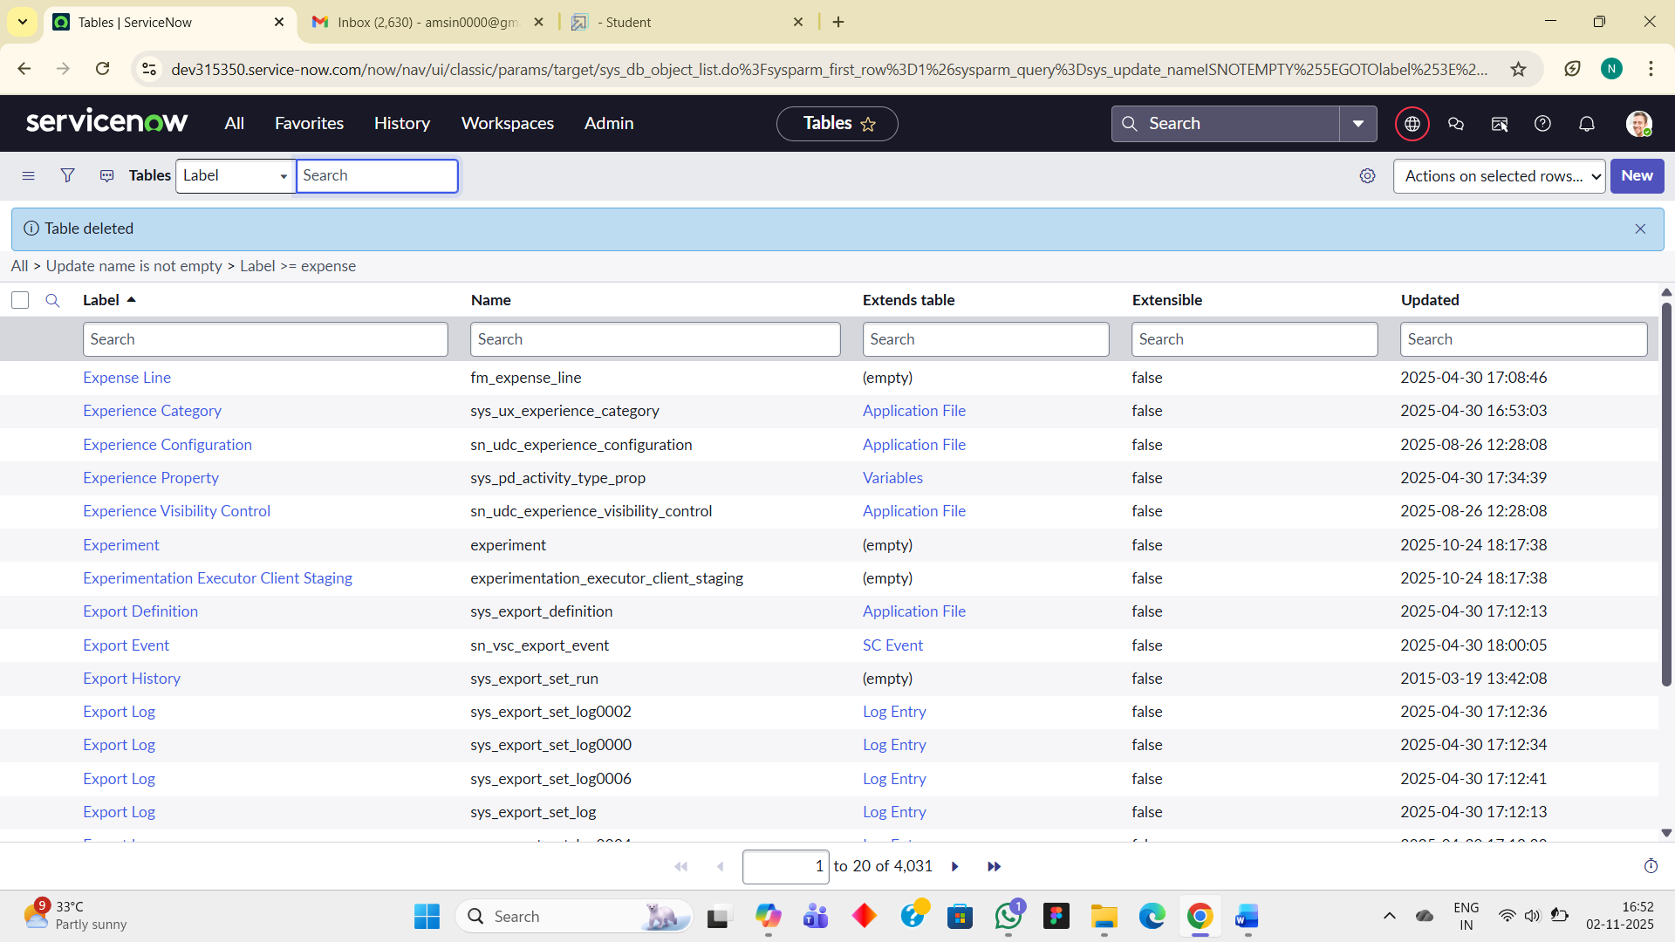

Parameter | Values
Model Summary | Validates entire workflow – creating tables, adding expenses, verifying automated total updates, and relationship visibility.
Accuracy | Execution Success Rate – 99%
Validation | All test cases passed – daily to family expense synchronization, auto-number generation, and field restrictions performed as expected.
Confidence Score (Overall System Reliability) | Confidence – 97% overall stability and data consistency confirmed.

